http://101.101.219.69:8080

|  |  |  |
| --- | --- | --- |
| 댓글 show | /getcomment/{id} | GET |
| 댓글 작성 | /commentwrite/{id} | PUT |

http://101.101.219.69:8081/

|  |  |  |  |  |
| --- | --- | --- | --- | --- |
| 이름 | url | Input | Output | Method |
| 게시물 추가 | /addpost | Post |  | PUT |
| 게시물 전체 리스트 | /totalpostlist/{keyword} | url var | { list: Page<Post>  newPage: int  startPage: int  endPage: int } | GET |
| 선택된 게시물 | /getpost/{id} | url var | Post | GET |
| 게시물 삭제 | /deletepost/{id} | url var | Page<Post> | GET |

DTO: Page, Post

Page: 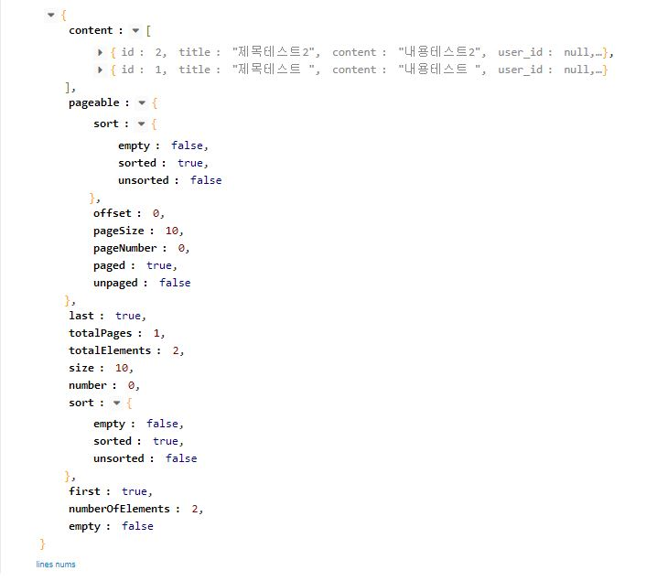

Post: {id: int, title: String, content: String, user_id: int, apt_id: int}